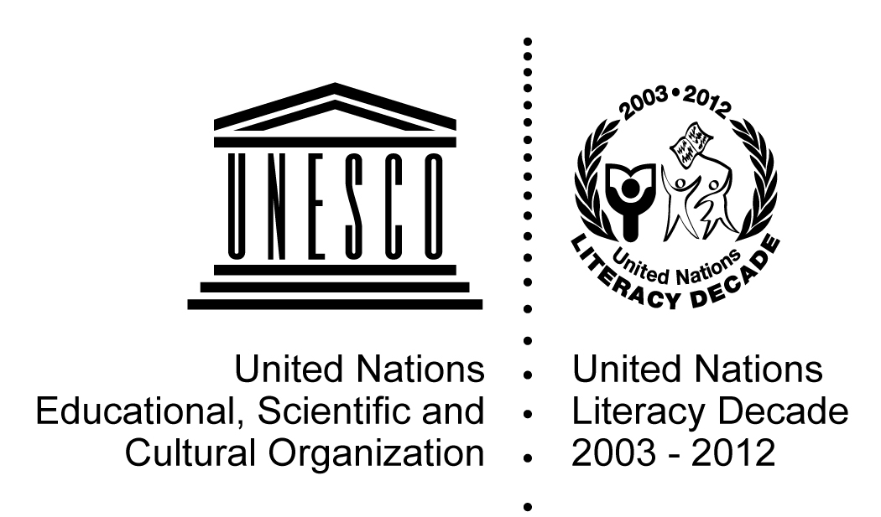 |  |  | UNESCO International Literacy Prizes 2015  ‘Literacy and the post-2015 Agenda’  Submission Form
1. Basic Facts
Title of programme/project:
Name of implementing Organization:
Chief Executive Officer of the Organization:
Country:
Starting year: Ending year: Ongoing:
Type of Organization: National Government National NGO International NGO Other National Institution
Other (Local branch of National NGO, Private body, Trade Union, Religious mission, etc.). Please specify
Operating in: Region Country District Province Community Other Please specify
Main partner(s):
2. Contact Details
Name of contact person:
Job title (or position):
Full Address: |  |  |  |  | Country:
Telephone/Fax: |  |  |  |  | Web site, if any:
E-Mail:
3. Implementing Organization
Describe the Organization, its history, its aims and mandate, its governance structure, any other relevant information (minimum 250 words):
4. Programme Summary
Describe the vision and rationale of the programme/project: the main goal and the particular problem/s it seeks to address (minimum 300 words):
5. Thematic Areas (tick those that apply)
- Areas focused by UNESCO International Literacy Prizes
Literacy in a multilingual context and promotion of the use of mother-tongue languages
Literacy and rural development
Literacy for out-of-school children and youth
Literacy for gender equality
- Areas that may be addressed by the post-2015 sustainable development agenda
Literacy for promoting inclusive and equitable quality education and lifelong learning
Literacy for skills development, decent work, economic self-sufficiency, inclusive, sustainable economic growth and poverty eradication
Literacy for promoting peaceful, inclusive and just societies for sustainable development
Literacy for reducing inequalities
Literacy and hunger, food security, improved nutrition and promote sustainable agriculture
Literacy and health and well-being
Literacy and environmental sustainability (e.g. sustainable use of terrestrial ecosystems, the oceans, seas and marine resources; sustainable management of water, forests, and energy; combating climate change, desertification and land degradation; conservation of biodiversity, sustainable consumption and production patterns)
Literacy for build resilient infrastructure, promoting inclusive and sustainable industrialization and fostering innovation
Literacy for making cities and human settlements inclusive, safe, resilient and sustainable
Other please specify:
6. Programme Details
a. Specific objectives |  | List and explain the specific objectives of the programme/project (150 words):
b. Outreach |  | Main target group(s): Adults (15 +) Out-of-school youth Women & girls Indigenous peoples Minority groups Other, please specify
 |  | Number of locations where the programme is running:
 |  | Number of participants reached annually:
 |  | Number of participants reached by the programme since its inception:
c. Programme delivery |  | Structure and organisation
 |  | How are the courses organized? Please describe:
 |  | What is the duration of the courses annually?
 |  | What is the duration of the courses in total?
 |  | What is the average number of learners per group?
 |  | Are there accreditation mechanisms in place? Please describe:
 |  | Teaching-learning: methodology
 |  | How are the learners’ needs determined? Please describe:
 |  | What kind of teaching methodology is applied? Please describe:
 |  | Teaching-learning content and material
 |  | How is the content of the curriculum decided? Please describe:
 |  | What kind of material is being used?
 |  | What are the main topics covered? Please describe:
 |  | How and by whom is the material developed?
 |  | Assessment, recognition, validation and accreditation of skills acquired
Is there any literacy skills development component?
If yes, describe how:
 |  | Does the programme issue any certification? If yes, describe how:
 |  | How the quality of the programme ensured?
 |  | Programme facilitators
What is the profile of a typical facilitator? Volunteer Paid Full-time Part time
Other, please specify:
 |  | What is the remuneration of the facilitators?
 |  | What is the learners/facilitator ratio?
 |  | Qualifications of the trainers/facilitators
 |  | How are the facilitators trained?
Does the programme provide training of trainers?
If yes, describe how:
 |  | Language(s) of instruction
 |  | Official language |  | Mother tongue |  | Other:
d. Use of ICTs |  | Are ICTs utilized in teaching or management of the programme/project? If yes explain how:
e. Funding | List and provide name of the main funding sources in order of importance:
e. Funding | Government
e. Funding | Private Sector
e. Funding | National NGO
e. Funding | International NGO
e. Funding | Foreign Donor
e. Funding | Self financed
e. Funding | Other (please specify):
f. Costs | Annual costs of the programme/project: (Local currency or USD )
f. Costs | Annual cost per learner:
g. Partners | Provide full list:
g. Partners | Provide evidence of commitment and support of the Government if any:
g. Partners | List contributions from the private sector and/or NGOs:
g. Partners | Other partnerships (please specify):
7. Programme Results
List and describe the achievements of the programme/project (minimum 150 words)
8. Monitoring, Evaluation and Impact (total minimum 200 words)
Do you undertake monitoring and evaluation of the programme/project during implementation? If yes, explain how:
Do you evaluate the outcomes of the programme? If yes, explain how:
Do you evaluate the impact of the programme? (i.e. on the quality of the learner’s life, his/her family and community). If yes, explain how:
9. Sustainability (total minimum 200 words)
Describe how the programme/project promotes sustainability (in terms of financial sustainability and/or local capacity to sustain the programme):
Is the programme/project being replicated elsewhere or scaled-up? Please describe:
10. Innovative Features
List and describe the innovative features of the programme/project (minimum 120 words):
11. Challenges and Constraints
List the main challenges and constraints encountered (minimum 120 words):
12. Relevance with the International Literacy Day Theme
Describe the relevance of your programme/project with the theme of the International Literacy Day: (minimum 120 words):
13. Additional Information
List any sources from which information regarding the programme/project is available:
14. Please list here documents in the following categories that will accompany this application
Documents, films, audio visual material available about programme:
Published research studies / reports available about the programme:
Internal or external evaluations of the programme, reports on impact assessments:
Teaching and learning material:
Date of submission form completion (MM/DD/YYYY):

The themes related to the sustainable development agenda are based on the 17 goals proposed by the Open Working Group https://sustainabledevelopment.un.org/focussdgs.html

