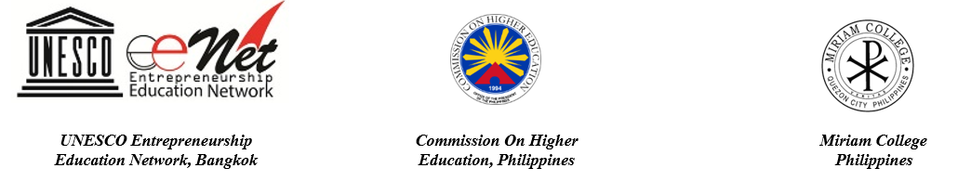
6th UNESCO-APEID MEETING ON ENTREPRENEURSHIP EDUCATION

Designing a Relevant and Innovative Entrepreneurship Education: Towards Mutual Recognition of Qualifications in ASEAN, East and South Asia
October 23-25, 2017, Manila, The Philippines

APPLICATION FORM
(Closing date: Friday, August 18, 2017)

First name: Last name:

Sex: Male Female

Job Title:

School/Institution/Organization:

Mailing Address:

City:…………………….. Post Code: Country:

Phone (office): Phone (mobile):

Fax: E-mail:

Website:

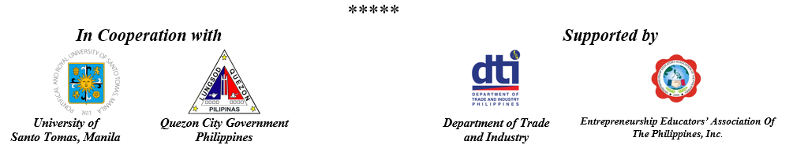

- Please highlight your main entrepreneurship education activities (max of 3 activities), providing a brief summary (max 100 words per activity)

- Please indicate how the meeting will contribute to your work on entrepreneurship education.

- Are you a member of the EE-Net? Yes No

If yes, please indicate briefly how you can benefit from, and contribute to, the network (max 100 words).

Closing date: Friday, August 18, 2017

Applicants from the Philippines, please send your applications to:

UNESCO EE Net Philippine Chapter – Miriam College
College of Business, Entrepreneurship, Accountancy
Katipunan Ave., Loyola Heights, Quezon City, 1108
Philippines
Email: unescoeenetphilippines2017mc@gmail.com

Applicants from other countries, please submit your applications to:

EE-Net Secretariat
UNESCO Bangkok
Thailand
Email: eenet@unesco.org

